### CS-639 Building User Interfaces, Fall 2019, Professor Mutlu

# Assignments — Week 09 | Design | Design Patterns

Design patterns are general, reusable solutions to commonly occurring problems in design. As in city planning and architecture, design patterns in UX development involve a hierarchy of patterns, starting at the conceptual level down to the low-level implementation of a component. [van Welie & van der Veer](http://welie.com/papers/Welie-Interact2003.pdf) suggested six levels: *business purpose*, *posture level*, *experience level*, *task level*, and *action level*. These levels make up a framework that helps designers analyze patterns in existing designs and utilize pattern to *generate* designs, following a top-down design process. In this assignment, you will use this framework to do both in the context of mobile fitness/calorie-tracking applications. First, you will identify an existing system (see [this link](https://beebom.com/best-calorie-counter-apps/) for an example list) and analyze the patterns used in its design. Second, you will use the framework to start designing your React Native 3 deliverable—a mobile fitness/calorie-tracking app. Below are the levels of the framework for reference.

**Levels of Pattern Languages in Interaction Design**

**Business Purpose.** Conceptual design that captures the role that the design plays in user's life, i.e., the mission of the application, e.g., "helping users achieve fitness goals."

**Posture-Level Patterns.** The structure that an application follows, i.e., what type of application it is, e.g., "a calorie tracking app," "a step counter app," or "a life coaching app."

**Experience-Level Patterns.** The *user goals* that make up the *user experience* that the application supports, e.g., activity tracking, coaching, and reviewing.

**Task-Level Patterns.** Design solutions that help users accomplish sequences of actions that make up user *tasks*, e.g., logging a meal, capturing a run, or completing a workout.

**Action-Level Patterns.** Design solutions that support the *actions* taken to complete the steps(s) of the user's task, e.g., a "start" button to initiate activity tracking, a selectable list entry for a food item.

**Step 1. Analyze an Existing Design.** In this step, you will identify a mobile fitness/calorie-tracking application. Before you settle on an application, study the landscape of applications (e.g., [search online](https://www.google.com/search?client=safari&rls=en&q=list+of+calorie+tracking+apps&ie=UTF-8&oe=UTF-8)) and choose an app that you think is well designed and clearly have patterns that you can analyze. For example, you should be able to easily identify the business purpose by looking at the developer’s website for the app or on the App Store/Google Play. Find/capture 3–5 screenshots that illustrate the main features of the app. There are two deliverables in this step. First, provide below your analysis of the patterns at each level below in the same way we have done in class using the analysis template (download [PDF](https://drive.google.com/a/wisc.edu/file/d/1UsIWkE4wLLJxxpFCidrchYEaGdkt5joY/view?usp=sharing), [PPTX](https://drive.google.com/a/wisc.edu/file/d/1j6kFvtGOKxcwlk6TUvnIo9MV5otv2uid/view?usp=sharing), [Keynote](https://drive.google.com/a/wisc.edu/file/d/136fjAkSGkiYffwNT2LmZ4bNd9N-B3xo3/view?usp=sharing) versions, or use the drawing below). Second, annotate the screenshots to highlight the *task-* and *action*-level patterns you can identify. You should be able to find at least 5 patterns for the Task Level and another 5 for the Action Level.

Customer satisfaction, Provide Information to users to achieve fitness goals

1. Add food to meal
2. Navigate to other days
3. Update stretch goals
4. See Nutrition pie chart
5. Edit/Delete the food item
6. Switch for reminder alarm
7. Add new alarm
8. Log the food ate for specific meals
9. Keep track of overall nutrition of the diet
10. Summary of the end goal
11. Set reminders to eat meals
12. See History of past meals

Have notification to remind user to log their meals

Keep a diary of past meals and daily calorie count

Link with other my fitness pal apps

A calorie tracking app for diet goals

**Business Goals**   
*Mission of the application*

**Posture Level**   
*‘Type’ of application*

**Experience Level**   
*User goals*

**Task Level**   
*Task sequences*

**Action Level**   
*User actions*

2

1

<annotated-screenshots>

E

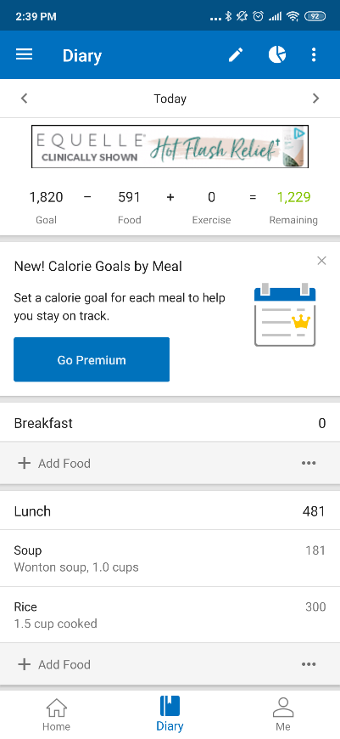

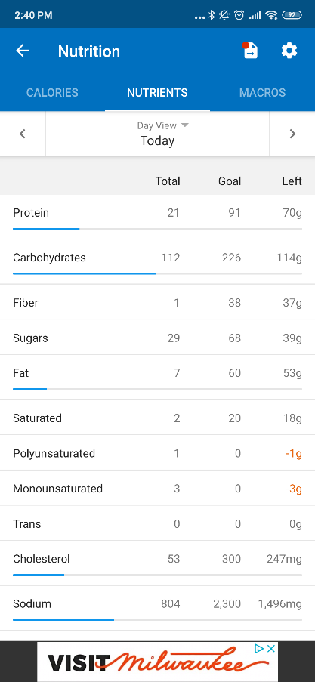

B

D

B

B

B

5

A

A

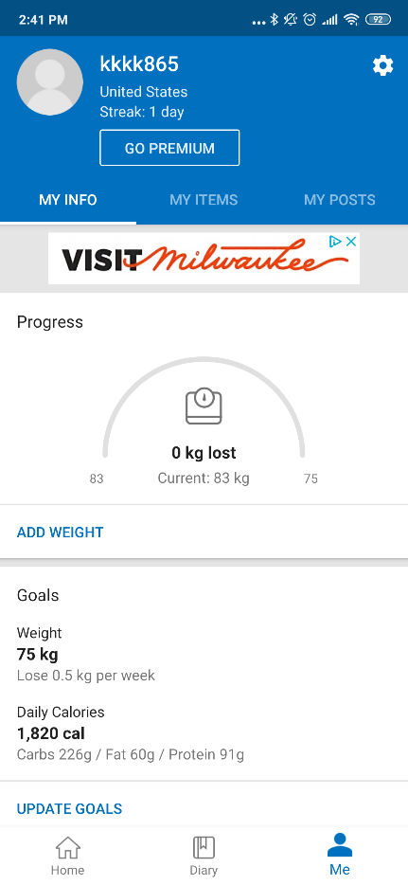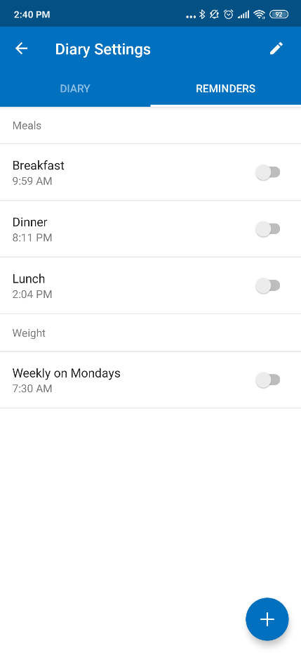

G

F

C

C

4

3

**Step 2. Generate Design.** In this step, you will follow the top-down design process using pattern languages to generate a lo-fi prototype design for your React Native deliverable. Although the deliverable will be constrained by the requirements of each React Native assignment, you will still be able to carry over some of your ideas from this assignment to your deliverable. To complete this step, using the template you used above, start making design decisions about your application, starting from the top and moving to the bottom. Consider what you want the *mission* (business purpose) of your app to be, what *type* of app it should be, and so on. Should it be motivational, providing messages to keep up the good work during the day, or more technical making sure that users are given detailed breakdowns of micronutrients? Outline your decisions in the analysis template below. Next, informed by your design decisions, create 3–5 (hand-drawn or digitally generated) ***wireframes*** of your envisioned application to show the task- and action-level components and annotate them to highlight the patterns. You should try to define 5 patterns in each category.

User satisfaction, promote healthy lifestyle

1. Let User define stretch goals
2. Keep a diary of the meals ate
3. Keep a track record of exercise, workout sets or distance ran
4. Add alarms to remind user to exercise
5. Recommend food based on calories left to intake and nutrition
6. Global Alarm switch
7. Add alarm
8. Update minor and stretch goals
9. Add exercise and add Food item
10. Show nutrition F. Show distance ran with pedometer

Log daily diet to visualize calorie consumption

Log daily exercise routine to visualize calories burnt

Calorie Tracking Application through diet and exercise

**Business Goals**   
*Mission of the application*

**Posture Level**   
*‘Type’ of application*

**Experience Level**   
*User goals*

**Task Level**   
*Task sequences*

**Action Level**   
*User actions*

<annotated-wireframes>

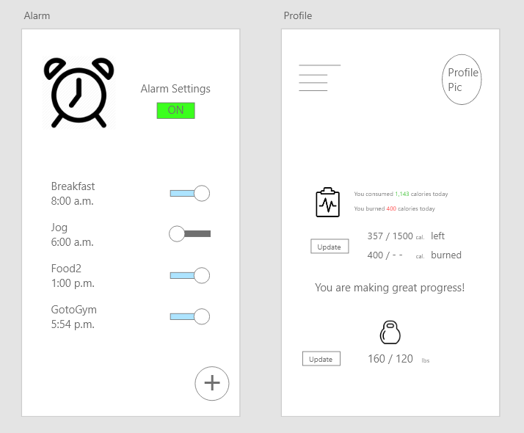

C

C

B

A

1

4

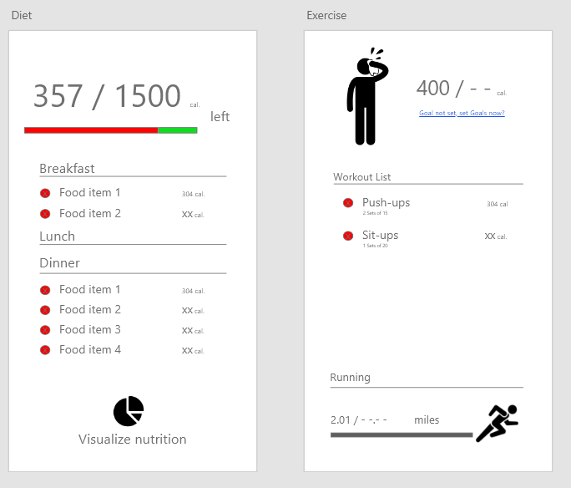

F

E

D

D

D

D

C

5

2

3